**Difference between Atkins, Paleo and Keto diet**

All the three diets are based on low-carb intake routine. But there is an essential difference between low carb diets too. Let’s study all of them and find the difference between low carb diets ourselves.

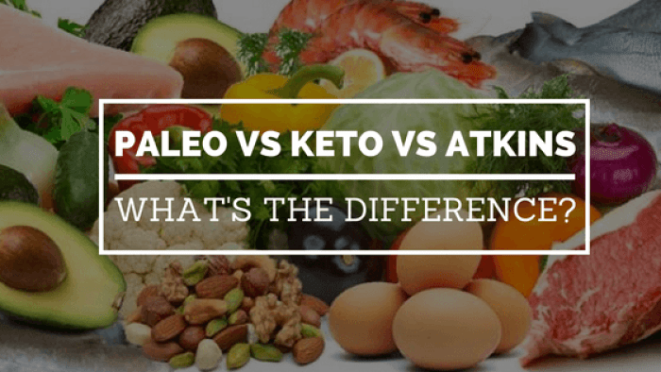

**Atkins diet**

Atkins diet includes carbohydrates restricted to just 20 grams in the initial phase and gradually increasing the number of carbohydrates week-wise. The amount of carbs rises until you get a balanced weight and don’t gain any more weight. The attractive offer that goes with the Atkins diet is: you can eat unlimited fats and protein as much as you like. You will find the difference between low carb diets when you will read the benefits provided by them.

Benefits of Atkins diet are as follows:

• You won’t feel hungry throughout the Atkins diet.

• Carbs are not difficult to avoid if you can satisfy your hunger through fats and proteins.

• Weight loss is easier. Mostly water weight is removed at first.

• There are pieces of evidence which show that cholesterol levels and blood sugar levels come under control through Atkins diet.

**Paleo diet**

There is a substantial difference between low carb diets. Paleo diet is a simple way of dieting with the elimination of processed food from the diet. Unlike Atkins and keto diets, the paleo diet doesn’t insist on a low-carb diet. The major fats stored in our body can easily be removed if we stop having mouth-watering dishes whenever we are “in a mood”. Taking a paleo diet may not help you lose much weight, but it leaves a fresh inside-body. Paleo diet and Atkins diet show the difference between low carb diets.

Benefits of the Paleo diet are as follows:

• The diet focuses on whole, nutrient-based food intake. So you get protein, fruits and vegetables and healthy fats to eat.

• Paleo diet is low-glycemic diet: reduces visceral fat and lowers blood sugar and cholesterol.

• You lose abdominal weight at ease!

• High in fibre than Atkins and Keto diets.

**Keto diet**

A keto diet is high in fats, low in carbs and moderate in protein intake. Keto diet focuses on getting the ketosis process active in your body so that it burns fat for performing various activities. You must have noticed the difference between low carb diets. Difference between low carb diets is clearly visible by comparing Paleo and Keto diet.

In addition to weight loss, keto diet disconnects a whole lot of medical issues away from the body. Specialists say the diet is so satisfactory that you just eat fewer carbs.

Benefits of Keto diet are as follows:

• Keto diet is more effective if you want to lose weight. Not just water weight, but beyond that.

• This diet helps in bringing down cholesterol levels and blood pressure.

• Improves acne and skin problems.

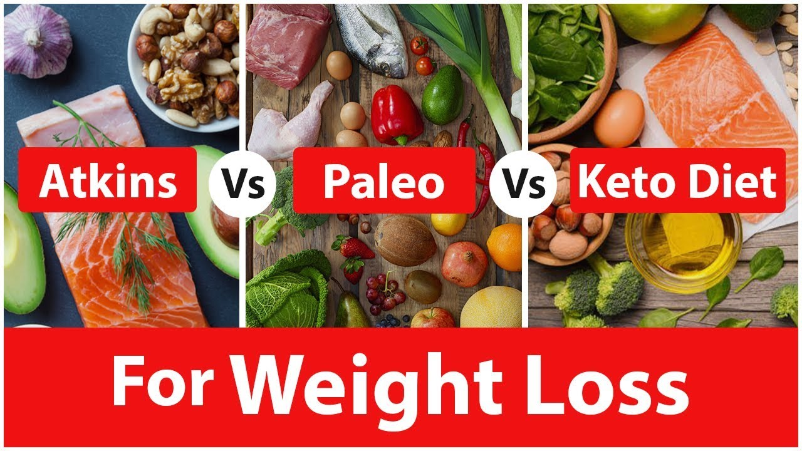• Since keto diet restricts intake of carbs, high levels of fat and proteins in food will satisfy your hunger.

**Difference between low carb diets**

Low carbs diets insist the body burn extra fats in the body for energy. This depicts the difference between low carb diets and low-fat diets. Low-fat diets insist on eliminating fats. It may barricade extra fats to settle but a low carb diet cuts the already settled fats.